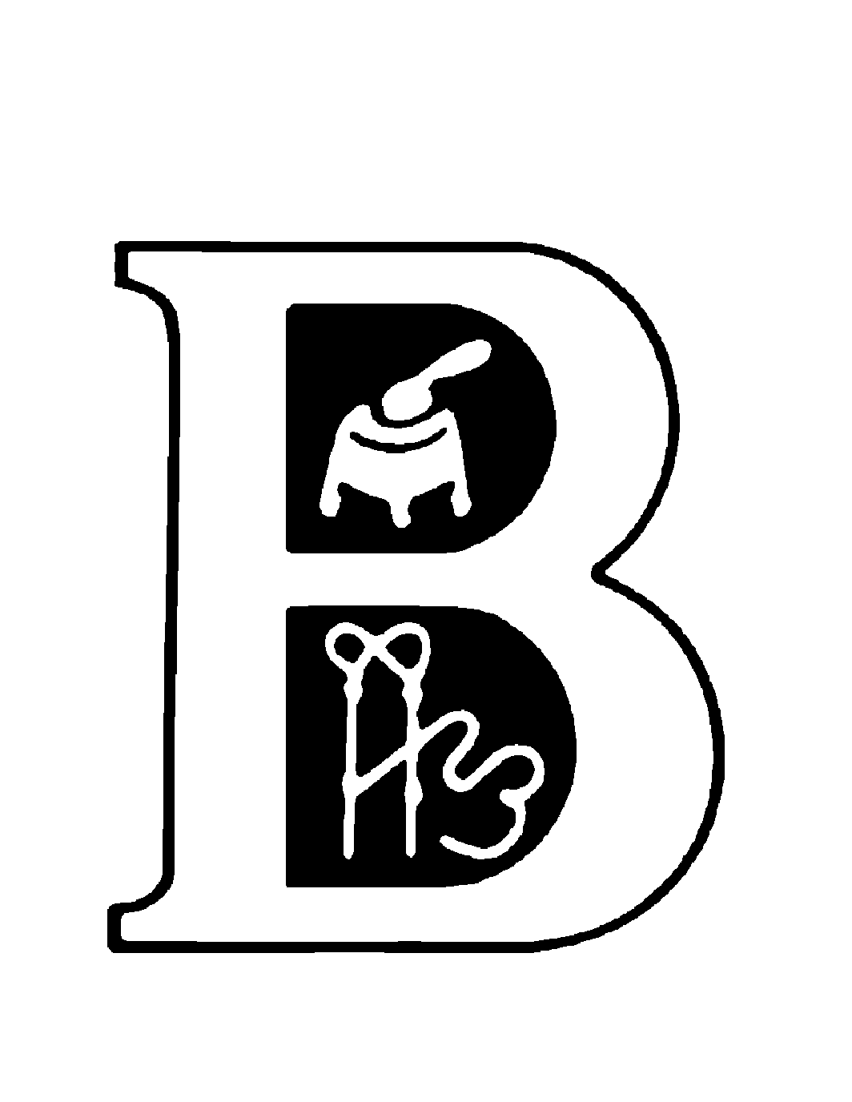
MSU Block and Bridle Club – Beef Expo Junior Show
April 4th – 5th, 2020
MSU Pavilion, 4301 Farm Lane, Lansing, MI
Overall Champion: $500
Res. Overall Champion: $400
3rd Overall: $300
4th Overall: $200
5th Overall: $100

Entries available at: www.canr.msu.edu/blockandbridle.com

Show Chairpersons:
Kollin Johnson Claire Vincent Lydia Acmoody Hunter Likavec
(517) 932-8621 (810) 941-7737 (517) 677-8262 (989) 387-4459
john7264@msu.edu vince173@msu.edu acmoodyl@msu.edu likavech@msu.edu

Changes for 2020
In conjunction with the MCA Expo committee, MSU B&B will be making stalling available in the main barn beginning at 10:00 a.m. Friday, April 3. This stalling (EARLY ARRIVAL ENTRY) will only be available for an additional fee of $10/head. Bedding will be provided in this area. This Early Arrival Entry must be made and paid for using the online payment! No mailed entries for early arrival will be considered. Stalls will be assigned, and it will be monitored. There are a limited number of these EARLY ARRIVAL spaces.

Stalling in the rest of the main barn will be assigned based on entry date (online or mail) and will be available after 5 p.m. on Saturday. Stalling will be available in the south barn beginning at 10:00 a.m. on Saturday, it will not be assigned.

Camping Fee payment will be available upon check-in. $20 per night

You may not enter the same animal in market heifer and a breed (or commercial) heifer division. They may only show in one or the other division.

Please watch our Facebook page and your email (provided on your entry) for details related to arrival and doors that will be available for unloading on Friday and Saturday.

Schedule
Friday April 3rd-
- 10 am – Early Entry Cattle can begin to arrive in the pavilion only early cattle stalling will be available (those who have paid the fee)!!!!
- **Early Entry cattle must be entered to show through the online payment portal ONLY!!
Saturday April 4th
- 10 am – Stalling in the South barn opens up (NO stalling assignments)
- 10 am – 4pm Cattle check in (steers and heifers), South Barn
- 5 pm - Cattle can enter the Main barn
- 7 pm – Showmanship begins
Sunday April 5th
- 8 am - Market Animal and Breeding Animal show begin

2020 Rules & Requirements
Please read carefully before calling with questions.

1. ELIGIBILITY: Open to youth that are between the ages of 8 and 21 as of January 1st, 2020. All cattle must be solely owned by the exhibitor making the entry. We welcome youth with a chronological age greater than 21 years of age who participate in 4-H or school activities with their developmental aged peers. (As recommended by the American with Disabilities Act). Please feel free to contact a committee chair if you have any questions.

2. ENTRIES: Entry fees are a non-refundable $50 for each entered animal. Entries must be postmarked on or before Friday, March 13, 2020. Late entries are $100 per head and will be accepted until Saturday, April 4th at 4 p.m. An exhibitor may enter up to 4 breeding heifers and 2 market animals. THE EXHIBITORS MUST SHOW THEIR OWN ANIMAL. ID MAY BE REQUIRED AT THE DISCRETION OF THE SHOW COMMITTEE. You MAY NOT enter the same animal in market heifer and a breed (or commercial) heifer division. They may only show in one or the other**
A complete entry consists of date of birth, breed of animal, and showmanship preference. Entries not providing all this information will NOT be accepted and will be required to late enter at check-in and pay the $100 late entry fee. Entry fees may not be transferred to another exhibitor. All cattle late entered will be required to pay the $100 late fee, with the exception of heifers purchased in the Expo sale on 4/4/2019.

Entries will also be accepted with online payment- https://form.jotform.com/200346630464146

Please send entries and entry fees to: MSU Block & Bridle Make checks payable to:
474 S. Shaw Lane Michigan State University Block & Bridle Club
1290 Anthony Hall
East Lansing, MI 48824
PLEASE Note: Stalling assignments in the main barn will be made based on entry payment date. Stalls will NOT be assigned in the south barn. As noted on page one, EARLY ARRIVAL with guaranteed bedded stalls, is available at a fee of $10 per head. All animals entered by an individual must include this stalling fee to be considered.

Stalling requests: There is no guarantee of stalling groups together, however we will do all we can to accommodate your request. Please include names of all youth in your group when completing online entries. Mailed entries should be made in a single envelope.

3. ARRIVAL: Early Arrival Entry cattle may arrive at 10 am on Friday April 3rd only if you paid the early arrival fee. Early Arrival fee ends March 13th and must be paid online. You may not pay an EARLY ARRIVAL entry fee upon check in on Friday/Saturday. All cattle entering at the regular fee may arrive on or after 10 a.m. on Saturday or report to tie outs.
Cattle stalled in the main barn can move in at 5 pm. Stalling chart will be posted for the main barn and there will be no stalling chart for the South barn. Cattle must be checked in by 4 p.m. on Saturday, April 4th.

NO CATTLE OR TACK ARE TO BE UNLOADED IN THE MAIN BARN (in the designated sale cattle area) BEFORE 5:00 P.M. ON SATURDAY! You will need to remain in the tie out area or stall in the south barn. Please be considerate of sale cattle being loaded out on Saturday afternoon near the main Pavilion. If cattle and/or equipment are in the main barn before the posted time you will be disqualified and asked to leave immediately. Stall assignments in the main barn are on a first entry basis until full. If you are not on the main stalling chart, you are to stall in the South Barn. Outdoor tie-outs will be available.

Cattle arriving from the Modified Accredited Zone must go to the show office and show their movement permit before unloading. Stall assignments in the main barn are on a first entry basis until full. If you are not on the main stalling chart, you are to stall in the South Barn. Outdoor tie-outs will be available.

4. PARKING: NO CATTLE ARE TO BE STALLED NEXT TO ANY TRAILER. Trailers MUST be parked on paved surfaces with the ONLY exception being near the South Barn. Vehicles and trailers can be parked in the lot across Farm Lane but NO cattle are to be stalled in/near trailers in this lot. Trucks and trailers will not be allowed to park in the grass/dirt area immediately west of the main arena.

5. STALLING REQUESTS: To specifically stall with another exhibitor, your entries must be received in the same envelope, stalling assignments are based on the date of receipt of the entries. Main barn will be assigned first and the south barn will not have assigned stalling. Entries done online should include the names of all youth that you would like to stall with. Exhibitors do not have to clean their stalls. Note: Entry of sale cattle does not guarantee the stall assignment of the purchased animal(s).

Bedding: Bedding is guaranteed for Early Arrival entry cattle only. Bedding will be provided in much of the other portions of the pavilion but is not guaranteed. No bedding will be provided in the south barn.

6.CHECK-IN: Check-in will be at the South Barn from 10 a.m. - 4 p.m. on Saturday, April 4th. Cattle CANNOT be in the Main Pavilion until 5:00 P.M. (except for those who paid the Early Arrival fee). Pick up exhibitor packets before taking cattle to check-in. Original registration certificates must be presented at check-in time. Tattoos and RFID tags (required) will be checked and must correspond to registration papers. Registration applications, faxes or photocopies will not be accepted. Animals can only enter the “check-in chute” one time.

**IF YOU HAVE A NONLEGIBLE/INCOMPLETE TATTOO, A NUMBER THAT DOES NOT MATCH THE REGISTRATION PAPERS, OR NO TATTOO, YOUR ANIMAL WILL BE PUT INTO THE CROSSBRED OR COMMERCIAL DIVISION. NO EXCEPTIONS. HAVE THE CORRECT TATTOO IN BEFORE YOU ARRIVE**

7. ANY OTHER REGISTERED BREEDS & COMMERCIAL/ MARKET HEIFER DIVISION: The AORB division will include all breeds not listed in the “show times and order” section. Market animals that are not registered will be shown in the crossbred steer, market heifer or commercial heifer division. Crossbred steers, commercial heifers and market heifers will be shown by weight. You may not enter the same heifer in the commercial heifer and the market heifer division. All animals are limited to show in a single division.

8. BREED REQUIREMENTS: For the following breeds, the animal must meet the percentage requirement listed below.
Angus Heifer & Steer- Purebred Angus registration paper
Char Composite Steer as well as Charolais/Char Composite Heifer (1 division)- Charolais Registration Papers
Chi Heifer & Steer- All registration papers issued by the ACA
Hereford Heifer & Steer- Purebred Hereford Registration Papers
PB Simmentals – 7/8 or greater
Percent Simmental – ½ to 7/8
Limousin Heifers – 75%
Maine-Anjou – 75% and above
Maintainers – 25% to 74%
Shorthorn- 15/16- purebred Shorthorn papers
Shorthorn Plus- 50% Steers & Heifers, Lower Percentage will be in AORB
AORB- any animal with breed papers that does not meet the requirement for the above breeds.
(Charolais steers, Limmi steers, Red Angus Heifer and Steers, any others not listed above).

9. PURCHASE OF SALE CATTLE: Heifers purchased in a breed sale on Saturday may show at the junior show on Sunday with no charge for late entry. You will need to provide:
a) a sale entry form signed by the sale clerk or manager
b) a bill of sale showing that the animal will be registered in the junior exhibitor’s name
c) a copy of the registration paper and d) a copy of the animal’s health paper (if purchased from an out of state consignor).

10. MICHIGAN OWNED: All cattle exhibited by Michigan residents are eligible for the Michigan Owned awards.

11. AWARDS: Top 5 Overall Market Animals and Breeding Heifers will receive $500 for Grand, $400 for Reserve, $300 for 3rd, $200 for 4th and $100 for 5th. Champion and Reserve Michigan Owned will be selected and awarded banners. Class and division premiums/prizes will be based off class size. NO REFUNDS FOR LOST PREMIUMS.

12. SHOWMANSHIP: NO-FIT. Exhibitors pre-register for showmanship on entry form and pay $5. After March 13th, showmanship will be $10 per exhibitor. Thus, participants can sign-up for showmanship during check-in times for $10. Showmanship will begin at 7p.m. Saturday evening. Classes will be divided by age as of January 1st, 2020. Exhibitors must show their own animal. Animals should be clean and dry with no adhesives, paint or similar products.

13. GROOMING REGULATIONS: ABSOLUTELY NO aerosol cans are allowed in the make-up area. Use of false tail heads or adding of hair or hemp is prohibited. Coloring agents may be used on the legs and tail. Be respectful of the Pavilion’s gates/panels when using aerosol cans.
NO forced administration of fluids to create gut fill will be allowed. Violation will result in the disqualification of the entry and exhibitor.

14. RESPONSIBILITY: The MSU Block and Bridle Club will not be responsible for any loss by death, injury, crippling, bruises, theft or condemnation.

15. Complaint Procedure: Complaints must be submitted in writing and must be accompanied with a $100 cash deposit. The $100 deposit will be kept and deposited into the Block and Bridle account, regardless of the outcome of the complaint. All complaints must be filed no later than 2 hours of conclusion of the show. All witnesses should be listed and signatures for each should be included with the complaint. Substantiated complaints may result in withdrawal of premium, ejection from current and/or future Junior beef shows and other MSU B & B events. Complaints that involve illegal activity will be turned over to the appropriate legal authority. The MSU B & B chairs will make final determination on complaints. MSU B&B also reserves the right to review any potential rules violation without the $100 fee.

16. PAVILION RULES:
- Alcoholic beverages prohibited. In accordance with University policy.
- NO fans are allowed behind the cattle or in the aisles unless suspended overhead.
- A maximum of one fan per three head of cattle is allowed.
- No generators will be allowed in or around the Pavilion.

17. DANGEROUS ANIMALS: Animals must be under control of the exhibitor at all times. If an animal becomes out of the exhibitor’s control two times within the ring, that animal will be excused from the ring. For safety, the show committee will request that dangerous animals be removed.

Breeding Heifers
1. SHOW ORDER: Heifers will show in the South ring beginning at 8 a.m. The show order will be:

- AOB
- Angus
- Charolais & Char Composite
- Chi
- Hereford
- Maine-Anjou
- Maintainer
- Limousin
- Purebred Simmental
- Percent Simmental
- Shorthorn
- Shorthorn Plus
- Commercial

2. Heifers born from September 1, 2018 thru September 31, 2019 are eligible to show. Commercial heifers should meet these same age requirements.

3. Registered heifers within breed will show from youngest to oldest. All heifers entered in a specific breed must be registered solely in the name of the youth exhibitor with their respective national breed association. Registration certificates must be presented at check-in time. All breeding heifers must be tattooed, and tattoos must correspond to registration papers. Heifers that are dual registered can show with only one breed and must be entered as such.

4. Commercial and market heifers will be shown by weight and all registered heifers will be shown by date of birth. Commercial heifers will compete for Supreme Heifer, and market heifers will compete for Overall Champion Market Animal.

Prospect Steers and Market Heifers

1. SHOW ORDER: Steers will show in the North ring at 8 a.m. In the following order:
1) AOB (All Other Registered Breeds) 8) Shorthorn Plus
2) Angus 9) Simmental
3) Chianina 10) Char Composite
4) Hereford
5) Maine-Anjou 12) Crossbred
6) Maintainer 13) Market Heifers
7) Shorthorn Top 5 Overall Market Animals

2.Prospect steers will be shown by breed and weight. All steers entered in a specific breed must be registered solely in the name of the youth exhibitor with their respective national breed association. Registration certificates or performance pedigrees must be presented at check-in time. All breed steers must be tattooed, and tattoos must correspond to registration papers. Steers that are dual registered can show with only one breed and must be entered as such.

3. Market heifers will be shown by weight. There will be no breed classes for market heifers, and they may not be shown in breeding classes.

Name/Tag/ID |  |  |  |  | Breed |  |  |  |  | Mkt H or Steer |  | Fee $$
Breeding Heifers (max 4) $50/head
Name |  |  |  |  | Breed |  |  |  | Date of Birth |  |  | Fee $$
 |  |  |  |  |  |  |  |  |  |  |  | Please make checks or M.O.’s payable to: MSU Block & Bridle. One check per family with all exhibitors listed may be sent. Mail to: MSU Block & Bridle 474 S. Shaw Ln, 1290 Anthony Hall, East Lansing, MI 48824
Camping ($20/space/night) |  | Number of Nights: |  |  |  |  |  | Number of Camping Sites:
Showmanship  $5 per exhibitor |  |  | Yes | No
Total Entry & Camping | $

MSU Pavilion, East Lansing, MI

Entries Due: March 13, 2020 Fee: $50/head --- Late Fee: $100/head

Please print legibly and include all exhibitor information. Use one entry form for each youth entering.
Entries must be postmarked by Friday, March 13, 2020.
Exhibitors’ Name: |  | Email: (print clearly)
Address: |  | County:
City: | State: | Zip: | Date of Birth: (mm/dd/yyyy)

Exhibitors are responsible for reading and adhering to the rules.
Please sign FULL FIRST AND LAST NAME below to indicate the rules have been read and understood.

_____________
Exhibitor Signature Parent/Guardian Signature

Stalling request: Stalling requests MUST be made by mailing all exhibitor entries together, NO EXCEPTIONS.

Do you have sale cattle stalls for Expo that you wish to retain: yes no
If yes, breed, farm name and last name the stalls will be under:

________________________________________________________________________________

REQUESTS TO BE STALLED IN SALE CATTLE STALLS MUST BE MADE ON THIS FORM OR THEY WILL NOT BE CONSIDERED, NO EXCEPTIONS. Entry of sale cattle does NOT guarantee stall assignments in sale stalls. Note: Stalling will be assigned on first come first serve basis, assignments will be made in the south barn after the main pavilion is filled.

TB and Health Requirements

TB Test Requirements

All Michigan cattle participating in the 2020 Michigan Jr. Beef Expo Show must have an RFID tag. Neither an official USDA alphanumeric metal ear tag nor an official breed registry tattoo will be accepted in place of an RFID tag.

All cattle exhibited at this event must meet the requirements for livestock exhibition as determined by the Michigan Department of Agriculture and Rural Development:
https://www.michigan.gov/documents/emergingdiseases/MDARD_TB_Zoning_Order_2018_FINAL-_DIGITALVERSION_wo_signature_619715_7.pdf

OUT OF STATE/ COUNTRY CATTLE –
- Out–of-state cattle must be accompanied by a certificate of veterinary inspection (health certificate) that lists the animal’s official identification EXACTLY as it appears on the animal.
- Official identification is either a USDA alphanumeric metal ear tag OR an official electronic identification tag (RFID tag) OR an official breed registry tattoo that is unique to that individual and corresponds exactly to the tattoo identification number on official breed registration papers. RFID tags can be purchased on site.
- For questions regarding requirements to move cattle into Michigan call the Michigan Department of Agriculture and Rural Development 517-373-1077.

Additional Health Requirement
Additional Health Requirements
- All cattle must be dehorned, horn length cannot be greater than two inches.
- Cattle infected with a communicable disease may not be brought to the show.
- Animals not meeting these standards are to be removed from the Pavilion immediately upon notification to the exhibitor and/or parents to retain his/her ability to exhibit in future B&B shows.

